CREATING IBM CLOUD SERVICE

|  |  |
| --- | --- |
| **Date** | 26 OCTOBER 2022 |
| **Team ID** | PNT2022TMID26841 |
| **Project Name** | Hazardous Area Monitoring for Industrial PlantPowered by IOT |

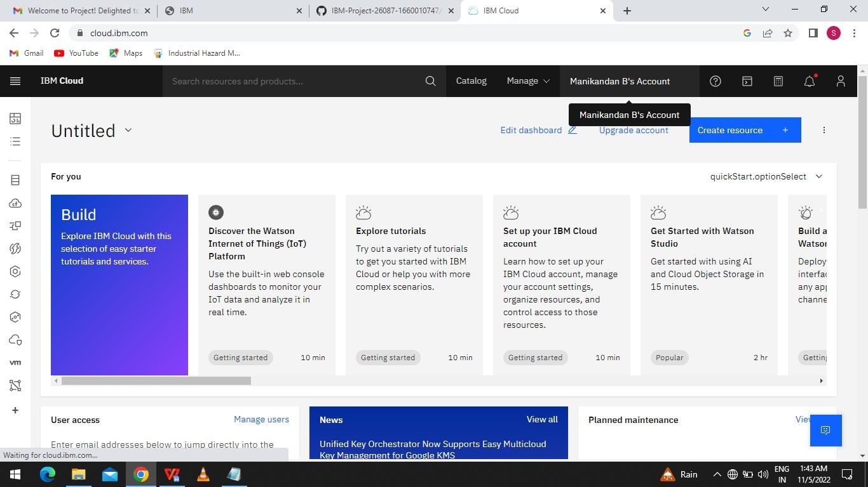

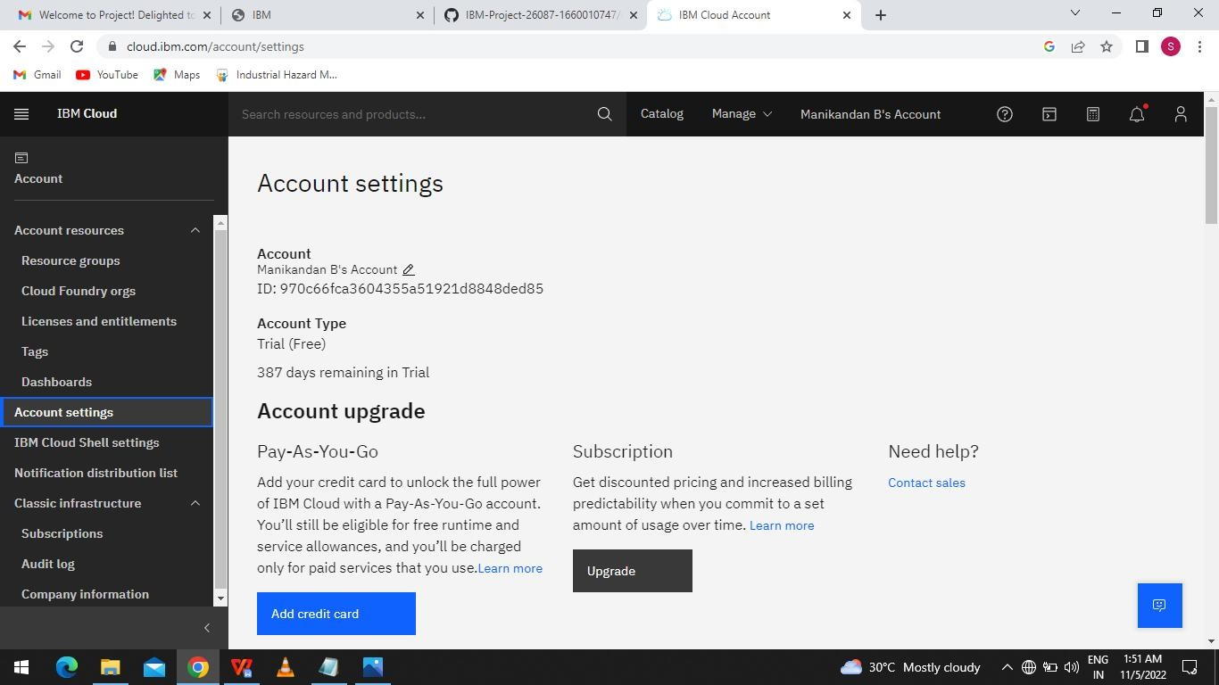

An IBM Cloud Service created Successfully .